W-16

**12 PHYSICS ATAR**

**PRACTICAL TEST - CIRCULAR MOTION**

**NAME: MARK:** 

The diagram underneath refers to an investigation performed in class where you investigated **the circular motion of a rubber stopper.** Remember the rubber stopper can have any speed at any radius because the person swinging the stopper around had control over how hard the string pulled in on the stopper. The masses hung from the string provided the pull on the string.



A Year Twelve Physics student wished to keep the force on the string the same whilst calculating the speed of the stopper at different radii.

1. Below is a list of events performed by this Physics student. Unfortunately they have scrambled the order around and need you to place the steps in the correct order in the space provided by **listing the correct order of the letters (A-E).**

**A.** Timed the stopper for 20 swings. The period is 1/20 of this time.

**B.** Repeated for at least 5 radii with the same mass on the string.

**C.** Put 100 g on the string and swung the stopper in a circle. The speed was adjusted to match the radius by lining up the tape mark.

**D.** The weight (tension T), radius r, period T and speed v were all tabulated.

**E.** The radius was set by putting some tape on the string just below the glass tube

(at about 50 cm when the stopper was swung).

(2 marks)

The student struggled to keep the marker in the same spot and estimated her uncertainties in the readings as indicated in the results table below.

The following **results** were obtained.

Mass of stopper used = 47.5 g

Mass of slotted weights used =100 g

|  |  |  |  |  |  |
| --- | --- | --- | --- | --- | --- |
| **Radius r (m)** | **Time for 20 swings (s)** | | **Average period T**  **( )** | **V =**  **(ms-1)** | **V2  ( )** |
| **Trial 1** | **Trial 2** |
| 0.30 ± 0.02 | 15.15 ± 2 | 15.20 ± 2 | 0.76 ± 0.10 |  |  |
| 0.40 ± 0.03 | 16.94 ± 2 | 17.00 ± 2 | 0.85 ± 0.10 |  |  |
| 0.50 ± 0.04 | 18.55 ± 2 | 18.90 ± 2 | 0.94 ± 0.10 |  |  |
| 0.60 ± 0.05 | 21.42 ± 1 | 21.22 ± 1 | 1.07 ± 0.05 |  |  |
| 0.70 ± 0.06 | 22.95 ± 1 | 22.85 ± 1 | 1.15 ± 0.05 |  |  |

2. Complete the table, remembering to complete any unfinished units that should appear in the column headers.

***(Do not include the absolute uncertainties - that will be tested in the following question.)***  (5 marks)

3. Consider the measurement: r = 0.30 ± 0.02. Calculate the % error in the measurement and therefore the absolute error in the measurement for the velocity (V) column.

(**Do not fill this answer in on the above table**). (3 marks)

4. (a) Using the graph paper provided plot a graph of **T** (y-axis) against **r** (x-axis), ***including the error bars for r = 0.50 ± 0.04***, and draw the curve of best fit through the points. (4 marks)

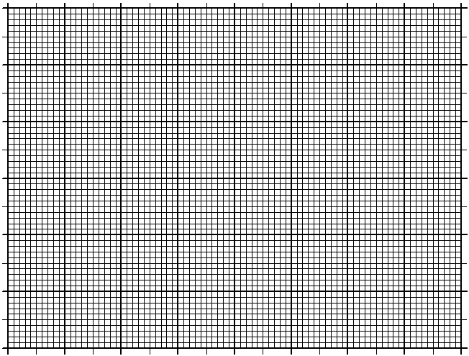

(b) What can you conclude from the graph about the relationship between r and T?

(1 mark)

5. (a) Graph the speed (v) versus the radius (r) in the space below.

(Plot v on the y-axis and r on the x-axis.) (4 marks)



(b) Graph the **speed squared (v2)** versus the **radius (r)** in the space provided below.

(Plot v2 on the y-axis and radius, r on the x-axis) (4 marks)



(c) What can you conclude from the graphs about the relationship between:

(2 marks)

(i) r & v?

(ii) r & v2?

(d) Determine the gradient of the graph in question 5(b) above. Be sure to indicate

on the graph which points were used. (3 marks)

(e) What does this slope represent? Compare it to the value obtained using the mass of the stopper and the centripetal force, and comment on the validity of the experiment. (6 marks)

(f) Supply an equation for the graph obtained in question 5(b) above. (2 marks)

6. Describe **three** errors affecting the results of the experiment above. (3 marks)

•

•

•

7. (a) Use a line of data (e.g. 0.60 m and the corresponding v2), together with the mass of the stopper, and calculate Fc = mv2 / r. (2 marks)

(b) Calculate the centripetal force by using the data for the slotted masses. (1 mark)

(c) Find the percentage difference between the differenct values of the centripetal force.

(2 marks)

(d) Give **three** reasons why the calculated Fc values differ. (3 marks)

•

•

•

8. Give **three** reasons why it is desirable to use 20 swings to calculate a value for the

period (T). Consider aspects of error and measuring difficulties. (3 marks)

•

•

•